APFNet Communication Guide

Asia-Pacific Network for Sustainable Forest Management and Rehabilitation

June 2016

Table of Contents
- Introduction and purpose 3
- The communication strategy and cycle 3
- Documentation 8
- Communication tools 9
  - Publications 9
  - Project websites 11
  - Social media 11
  - Photographs 11
- APFNet visibility 13
  - Applying visibility at intervention sites and events 13
- Recommended CV&D outputs by intervention size 13

Annexes
- Communication strategy template
- Guide to developing communication objectives
- Documentation guide
- Guide to web writing
- Good practices in newsletter development
- Guide to writing press releases
- Stories of change guiding questions
- Guide to good photography
- Design files (source files for logos, etc.)

Introduction and purpose

Effective communication, visibility and dissemination (CV&D) activities are essential in APFNet projects, programs, mechanisms and other activities for ensuring the accountability of executing agencies (EAs) and continued support for APFNet among key stakeholders and the wider public.
The APFNet Communication Guide provides general guidance and good practices on recommended CV&D activities in APFNet-funded projects, programs, mechanisms and other activities (collectively called “interventions” in this guide. The term “projects” is used in sections of the guide aimed specifically at interventions implemented by EAs). The guide also sets out the recommended CV&D outputs that interventions should produce specifically for use by the APFNet Secretariat.
The guide, therefore, has two main purposes:
- To assist EAs, APFNet Secretariat staff and other partners in developing and implementing communication strategies to communicate their work effectively to target audiences.
- To set out the nature and frequency of communication products that EAs and partners should develop specifically for use by the APFNet Secretariat in its efforts, to disseminate the lessons learned in APFNet-funded interventions to target audiences.
Requirements to implement CV&D
CV&D activities should be planned carefully from the initial stages of any intervention to
maximize its impact and cost-effectiveness. This includes new project proposals, which are required to include a communication strategy that conforms to this guide, including a proposed budget. Projects already underway or approved should make strong efforts to develop and implement communication strategies using existing resources. The APFNet Secretariat and EAs should work closely together to ensure the effective implementation of CV&D activities in accordance with this guide.

The communication strategy and cycle

A communication strategy is defined in this guide as a document that sets out an
intervention’s CV&D objectives, target audiences, budget, work plan and mode of
evaluation. It should guide media and public relations activities and ensure that such activities are cost-effective and serve strategic purposes.
All APFNet-funded interventions should have communication strategies to ensure that knowledge and information are disseminated effectively to target audiences with the aim of scaling up successes, influencing policies in government and the private sector, and informing future interventions.

3

In general, developing and implementing a communication strategy consists of the following steps:

1. Goals and objectives
2. Target audience
3. Key message(s)
7. Documentation
& Monitoring
4. Timing and budget
5. Work plan and tools
6. Evaluation

Figure 1. The communication strategy cycle

Annex A contains a simple template for a communication strategy, which can be filled in using the guidance below.

Step 1) Setting your goals and objectives
A communication objective is a target which specifies the intended audience, the type of change that is expected, when and where the communication activity is to take place and finally, what criteria will be used to measure its degree of success. They are focused on changing the knowledge, attitudes and behavior of individuals.
Good communications objectives should meet these criteria: outcome oriented (changes in
people’s knowledge, attitudes, behavior), measurable, time limited, specific, and. practical (achievable and appropriate).
When developing objectives, ask yourself: What do you hope to achieve as a result of your
communications activity? How does the communication objective fit in with the overall
objectives and goals of your program or project?

Annex B contains a simple example and template for developing communication objectives.

4

Step 2) Identify your target audience
Who is your target audience?

The more refined the target audience description, the more precise and effective your communication will be. “General public” is not a target audience. Be as specific as possible and include age, gender and the location of the audience.
In general, target audience can be split into two types:
- Primary Target Audience – These are the key persons or groups you communicate to directly.
  - For example: Forestry students in APFNet member countries – men and women aged 18-25.
- Secondary Target Audience – people who will also benefit from hearing the messages or people who influence your target audience now or in the future.
  - For example: Campus leaders such as professors, heads of student bodies and other organizations.
Current attitudes, habits and knowledge of your target audience

The better you define your target audience, the more you will understand them: how relevant & engaged is the target audience in the issue?
What is their level of knowledge and attitude on the subject you are communicating? What are their beliefs on the issue? What might be their motivation for or barriers to hearing, believing and accepting the information? What would persuade them? What is the ‘language’ (how they speak)? Where do they live? Where do they get their information?
Desired response from your target audience

How do you want your target audience to feel? What do you want them to do? The following are some examples of what you might want them to do:
- Sign a petition
- Change their awareness, attitude or behaviour

5

After you have selected your target audiences for every communication objective, it’s important to decide what you are going to say to them to increase their knowledge,
influence their attitude or make them change their behavior.

A key message sums up your message in a short statement. Your key message has to
include a benefit for your target audience, otherwise they won’t be willing to change. Examples of why people would be willing to change behavior:
- E.g. Local communities may change their behavior because:
  - It will protect them from damage and danger
  - It will create opportunities for new sources of income
A key message and call to action should be developed for each target audience.
A call to action describes exactly what you want your target audience to do – this is your target for a specific target audience. This target should support the achievement of your
communications objective. Example of key message:

Call to action
As the demand for land intensifies, local people and governments are facing increasing pressure on land resources. Community forestry offers an opportunity to improve local livelihoods, reduce deforestation and improve forest quality, and strengthen good governance.
Together we can promote community forestry by increasing forest area under community management; strengthening the active control of communities over their forests; and ensuring that institutions are able to effectively implement CF laws in their country.

A slogan can be developed based on your key messages. (Note: a slogan is typically used as a tool to deliver a key message in a concise and attention-grabbing way, but the slogan itself is not a key message!)
Example of slogan:

Local people hold the key to healthy forests.

6

Timing is essential and needs planning. You need to identify the best time to communicate (taking into account what might be happening externally and internally around the topic that could either help or hinder your effort).
When would be the best time to communicate over the next 12, 24 or 36 months? What would be the best time to launch your effort? Are there key events throughout the lifecycle of your campaign that you could exploit and more effectively push your message?
Managing your budget is an integral part of making your communications effort a success.
- How much money do you need to execute the entire campaign, and to maximize value for money?
- How much money is readily available?
- How much money will be available in the future?

Step 5) Develop work plan and select communication tools
The communication tool(s) you will use is dependent on the answers to the above questions: what you want to achieve, the message you want to communicate, your target audience, the profile of this audience, your timeline and resources available.
Below are examples of various communication tools to consider. Section 4 of this guide provides full descriptions of some of the common tools.
Table 1. External Communications Mix
Press  - Press release  - Radio  - Opinion editorial  - Features  - Features advisories | Television  - News and features  - Long-format programs and online television options | Print  - Brochures  - Posters  - Letters  - Leaflets  - Magazines/comics  - Reports  - Academic journals | Online  - Website  - Online campaigning  - Social networks (e.g. Facebook, Twitter)  - Web videos  - Online games, photo- galleries, - cards ... etc.  - E-newsletter
Face-to-face  - Meetings/workshops  - Community discussions | Public relations  - Events/stunts  - Endorsements  - Telephone calls  - Conferences | Advertising  - Print  - Radio  - Television

Table 2. Internal Communications Mix
Face-to-face
- Meetings/workshops
- Conference/Skype calls
Electronic
- Emails
- Webcasts
- E-groups, intranet
- Online courses

7

Step 6) Evaluate successes and lessons learned
How will you know if you have succeeded and met your objectives? How are you going to evaluate your success? What performance indicators and evaluating measures will you use? It is important to assess your efforts so that any changes, if necessary, can be made when engaging in a similar effort in the future.
Some questions to ask when evaluating the success of your communication efforts:
- Have you achieved your objectives?
- Did you reach the right audience?
- Did they understand what the message was and did they respond in the way you intended?
In order to evaluate effectively, your evaluation plan must be built into the communication work plan first. Some techniques for evaluation include:
- Periodic surveying or tracking, stakeholder surveys given to peers, focus groups
- Forms to evaluate changes in awareness, knowledge or actions taken
- Tracking responses (requests for information, website hits, number of downloads, e- news or email subscriptions, etc.)
- Monitoring media and third-party use of key messages.

Step 7) Documentation and monitoring (ongoing)
While not a standalone step on its own, documentation and monitoring should be done on an ongoing basis throughout the communication cycle. Documentation ensures that all materials, information and documents produced throughout the project are organized and stored for future reference and use. Meanwhile, monitoring should be carried out to collect success and performance indicators as planned in Step 6 of developing your communications work plan.

Documentation

Documentation is the process of compiling, organizing and storing materials and documents. It is a component in the continuum of information gathering—knowledge development— communication planning. It is a key ingredient in successful project management and essential for effective communication, but it is often overlooked because many people find it very hard to do. Nevertheless, a well-designed documentation process is deceptively easy to implement.
Annex C sets out a simple process for project documentation. The aim of the annex is to ensure that important activities between the inception, progress and final reports and other activities are properly recorded and infused into these documents, and to systematize the documentation process.

8

Communication tools

This section outlines the most common CV&D activities that should be carried out in APFNet-funded interventions, especially projects. EAs are encouraged to identify the most
appropriate means of adding CV&D value to their projects and to discuss with their APFNet project managers how CV&D might be incorporated in project workplans and deliverables. Project proposals should include a CV&D plan and budget1 and explanations of how the CV&D plan will add value to the project.
Publications released in print or electronic form should include the following disclaimer:

This publication is an output of a project implemented with the financial and technical assistance of the Asia-Pacific Network for Sustainable Forest Management
and Rehabilitation (APFNet). The views expressed in this publication do not
necessarily reflect the official opinion of APFNet.

Publications

    - Web news
The APFNet Secretariat uses the APFNet website as its main communication platform for disseminating information on its activities to focal points, high-level stakeholders and the public. For this reason, it is important that submitted materials intended for publication on the APFNet website are written clearly and concisely and in a way that captures the interest of readers. Annex D contains general guidelines for writing web content.

Recommended frequency

Web news stories should be prepared and submitted to the APFNet Secretariat as soon as possible following the implementation or completion of major achievements, events or other deliverables (such as the release of a study or publication, or formation of new partnerships). EAs are responsible for monitoring project workplans and for coordinating
with their designated APFNet project managers in preparing web news submissions. Items may also be submitted before major events, such as conferences and workshops, for listing on the APFNet website as a way of gaining publicity for them.
    - Project newsletters
Newsletters can be useful for showing the progress being made in projects and for drawing attention to important events. Project newsletters typically contain articles on accomplishments and on previous, ongoing and upcoming activities. They may also include

1 Where feasible, communication products should be edited by a professional editor or native English-speaker before submission to the APFNet Secretariat. Such editing should be included in the CV&D plan and its cost added to the budget.

9

interviews with stakeholders, policymakers, experts and observers, and other features. Newsletters should include illustrative photographs (see section 6.4).
EAs are not required to follow a specific newsletter template. Annex E provides a set of good practices that may assist in newsletter development.

Recommended frequency
EAs may decide to publish newsletters in their local language(s), the timing determined according to needs. All large projects should aim to publish dedicated project newsletters (either in print, or electronically) in English at least once per year. The articles may be used for integration with APFNet organizational newsletters.
    - Leaflets, flyers, posters and brochures

Printed or electronic leaflets, flyers and brochures are useful for publicizing information to wide audiences. Flyers, leaflets and posters tend to be single-sheet materials used to announce events, present simple facts or convey important messages. Brochures tend to contain more detailed information in multiple pages or panels.
    - Press releases
A press release is a short (1–2 page) document announcing, for example, a (forthcoming or just-ended) event, a newly released publication, or the findings of a recently completed study. Generally, press releases are designed to whet the appetite of journalists so they are encouraged to investigate the story further and report on it. In conjunction with direct contact with journalists, press releases can be cost-effective ways of disseminating information on interventions, attracting media coverage of events, and promulgating the lessons learned from studies and interventions. Annex F contains a simple guide to writing press releases.

Recommended frequency
EAs should prepare and issue press releases, as required, in conjunction with newsworthy events (e.g. conferences and workshops), publications and announcements.
    - Stories of change

Stories of change are potentially powerful ways of conveying the impact of interventions by, for example, telling the stories of individuals in communities. One common approach of developing stories of change is to identify individuals whose lives have changed (ideally at least partly as a result of an intervention). Explore with that person, through conversations, what her or his life was like before the change, what sparked the change, and what is the situation now. Then draw wider conclusions about the impact of the intervention or the
lessons to be learned from the story. Annex G lists some questions to consider in developing stories of change.

10

Recommended frequency
Stories of change are usually prepared towards the end of (or even after) an intervention; Table 3 sets out the recommended number of stories of change, by intervention size.

Project websites
The development of websites or (subsites in other websites) is encouraged for interventions seeking a wide impact. EAs that develop dedicated project websites or subsites should do so in close consultation with their APFNet project managers. APFNet should be informed when websites are launched so that links can be established between the project website and that
of APFNet. Websites should include the following disclaimer:

This website is an output of a project implemented with the financial and technical assistance of the Asia-Pacific Network for Sustainable Forest Management and
Rehabilitation (APFNet). The views expressed on this website do not necessarily
reflect the official opinion of APFNet.

EAs and other partners should acknowledge their partnerships with APFNet in suitable ways on their websites or subsites. This includes placing the APFNet logo in a prominent position, accompanied by text such as:
This project is the result of a partnership with the Asia-Pacific Network for Sustainable Forest Management and Rehabilitation (APFNet), [list other involved
partners]. The [name of organization] gratefully acknowledges the financial and
technical support of APFNet in the implementation of this project.
Where possible, links should be made to the APFNet website using the following URL: www.apfnet.cn. The APFNet Secretariat will publish dedicated news items on its website to
boost the visibility of project websites.

Social media
The use of social media can be effective in sharing information with people at the individual, community and organizational levels and for obtaining feedback. Social media can help raise awareness of intervention activities and objectives and provide followers with interactive experiences. APFNet encourages EAs and other partners who operate their own social media accounts to expand and strengthen the advocacy work of their interventions through social media. APFNet’s visual identity and website links may be used where feasible and appropriate.

Photographs

Good-quality, systematically organized photographs are essential for illustrating the purposes of interventions and showing the benefits they provide. EAs should plan their
approaches to obtaining a photographic record of their field sites, activities, staff and
stakeholders. In each APFNet-funded intervention, the aim should be to show the diverse activities undertaken, the landscape (and potentially social) changes brought about over

11

time, and the beneficiaries of outputs and outcomes. APFNet particularly seeks the following types of photos:
- Field sites – photos should be taken in a way that maximizes the comparability of photos as sites change over time. Thus, photos should be taken at the same
locations and from the same angles at regular intervals. Other photos of field sites should aim to show activities being undertaken, the landscape context, issues that are being addressed by the intervention, and local biodiversity.
- Nurseries and seedlings – photos should show the various species being grown, the general nursery site, nursery activities being undertaken, and any innovative aspects of nursery management.
- Local communities and community activities – photos should show local people engaged in intervention activities with the aim of capturing the human and social dimensions of the intervention.
- Events (workshops, meetings and conferences) – photos should be taken of keynote speakers, experts and other people engaged in conference activities and presentations. Photos should also capture other proceedings during the event, such as networking sessions, working groups, coffee breaks and the audience at presentations. Informal shots are usually more effective than posed photos in capturing the dynamic nature of events.
All photographs should be accompanied by the following information: photographer’s name,
the date and location of the photo, the activity shown in the photo, the names of people in
the photo (where available), and other relevant information. Annex H provides a guide to good photography.
All interventions should designate a contact person responsible for taking, compiling and documenting photos. This person should also be the main contact for submitting photos to the Photo Management Officer at the APFNet Secretariat.

Recommended frequency

Photos should be taken during all field visits as well as at conferences, workshops and other events, and stored systematically to ensure that the context, date and other information is clear. Photos of intervention sites, nurseries/seedlings and local stakeholders should be submitted with progress reports. Photos of events and other proceedings should be submitted as soon as the event has been implemented, along with the web news story. Where photos are designed to show changes to landscapes over time, they should be taken at planned intervals (e.g. quarterly, half-yearly, or annually).

Technical parameters and quality requirements
Given that photos are used in print and online publications of varying types and sizes, digital photos should have a minimum resolution of 300 dpi at the desired size of publication, which usually equates to a file size of more than 2 MB. This resolution should be obtainable from any mid-to-high-range point-and-shoot camera. The use of cell-phones as cameras

12

should be avoided unless they are able to provide photographs of sufficiently high resolution and clarity.

APFNet visibility

All interventions should appropriately acknowledge the role of APFNet as a contributor (of
funds, oversight and expertise) and to help raise APFNet’s profile. This includes displaying the APFNet visual identity at intervention sites and incorporating written, verbal and visual recognition of APFNet’s role in publications, press releases, interviews, websites, and other dissemination materials.

Applying visibility at intervention sites and events
APFNet’s visual identity should be displayed at intervention sites (e.g. in permanent signs) and at workshops, conferences and other related events. This includes displaying the logos of APFNet, EAs and other partners on items such as:
- Field signs
- Banners and display panels
- Publications (e.g. newsletters, brochures, reports and flyers)
- EA and other partner websites
- Audio-visual items.
Logos should be accompanied by text (in the appropriate language(s)) such as:

Local people hold the key to healthy forests. This project is the result of a partnership with the Asia-Pacific Network for Sustainable Forest Management and Rehabilitation (APFNet), [list other involved partners]. The [organization] gratefully
acknowledges the financial and technical support of APFNet in the implementation
of this project.

Recommended CV&D outputs by intervention size

As set out in its communication strategy, an intervention may involve the use of a range of communication tools and outputs designed for local, national or international audiences and to meet the communication aims of the intervention. Table 3 provides an indicative guide to the types of CV&D outputs that could be produced specifically for the APFNet Secretariat, by size of intervention. Section 4 of this guide provides full descriptions of the listed activities.

13

Table 3. Indicative CV&D outputs for APFNet Secretariat, by size of intervention2
Duration of intervention | Recommended outputs and description
Small (less than 1 year) | - News items on major achievements (e.g. release of studies, publications, significant developments) for the APFNet website or for release to the press  - 1 story of change  - Photos of activities, intervention sites and stakeholders
Regular (1 to 3 years) | - News items on major achievements (e.g. release of  studies, publications, significant developments) for the  APFNet website or for release to the press  - 3 stories of change  - Photos of activities, intervention sites and stakeholders
Large (more than 3 years) | - News items on major achievements (e.g. release of studies, publications and other significant developments) for the APFNet website or for release to the press  - 1 edition of newsletter per year  - 5 stories of change  - Photos of activities, intervention sites and stakeholders

2 New intervention proposals are required to include a communication plan that conforms to this guide, including a proposed budget. Interventions already underway or approved should make a strong effort to develop and implement a communication plan using existing resources.

14

Annex A APFNet Communication Guide

Annex A
Communication strategy template
Name of project: Start/End year:
Communication strategy
Objectives | Target audience | Key message | Communication tools
 |  |  | Products/Tools | Media/Channels/Activities
Project objective
1.
Communication objectives
1.
2.
3.

Workplan and budget
Activities (what) | When | Who | Estimated budget
Development and production of communication tools/products
Prestesting of tools/products
Production of tools/products
Dissemination of tools/products
Monitoring and evaluation
Etc.

Monitoring and evaluation
Communication objectives | Success indicators | What information to collect | How to collect information | Who will collect the information | When to collect information
1. | 1.
 | 2.
2. | 1.
 | 2.

Annex B
Guide to developing communication objectives
What is a communication objective?

A communication objective is a target which specifies the intended audience, the type of change that is expected, when and where the communication activity is to take place and finally, what criteria will be used to measure its degree of success.

How to write communication objectives: The ABCD approach

A - AUDIENCE: Specify a single priority group

B - BEHAVIOR: Define the type of change or changes you expect

C - CONDITION: Determine when and under what conditions you expect this change to occur

D - DEGREE: Specify how much change you expect and how you will find out if it has happened

Communication objectives template

 | Audience group | Behavior | Condition | Degree
Description | Specify a single priority group | Define the type of change or changes you expect | Determine when and under what conditions you expect this change to occur | Specify how much change you expect and how you will find out if it has happened
Example | Farmer association president, women leaders, etc. | Should be able to give simple explanation of forest conservation | Six months after communication campaign activities | At least 50% of participating farmers are able to correctly explain forest conservation
Example from your project

Annex C Documentation guide
Overview

In projects, documentation is a critical component of the continuum of information gathering—knowledge development—communication planning. It is a key ingredient in successful project management and communication, but it is often overlooked because many people find it hard to do. Nevertheless, a well-designed documentation process is deceptively simple to implement.

The aim of this guide is to ensure that important activities between the inception, progress and final reports of projects and other interventions are properly recorded and infused into these documents, and to systematize the project documentation process. It is intended for all activity leaders or designated documenters.

The following sections explain the importance of documentation and walk you through its five main steps.

- What is documentation?

Documentation is the process of recording – in written, numerical, photographic/visual or other form – the ideas, strategies, procedures, activities, etc., generated in a project. In development projects, documentation mainly refers to the recording of activities such as field visits, field work, meetings, training and workshops. Note that not everything can or should be documented – an important part of the documentation process is deciding what data need to be collected, stored, processed and communicated, and what data can be ignored.

- Why is documentation important to your project?

Documentation is important for four major reasons, as follows.
  - Project documentation helps in generating knowledge (by providing a systematic record that can be drawn on) and, ultimately, in sharing it (i.e. communication).
  - Documentation allows you and others to go back in time (without the use of a time machine!) and learn from your successes and failures. It empowers you to work on the causes of the problems rather than on “fixing the problems”. The documentation of successes can enable (and inspire) others to replicate or improve on existing methods and to avoid repeating mistakes.
  - The documentation of procedures and strategies keeps everyone in the project team on track and on the same page. A well-documented project is efficient because it helps to focus and direct the team. Even if staff members are replaced, the project can continue in the same direction because the documented procedures guide newcomers in performing future and routine tasks.

  - Documentation gives you a clear picture of the status of your project because well- collected data that are properly organized and recorded provide objective evidence of project impacts. Adequate documentation helps inform critical decisions, increasing the likelihood that good decisions will be made.

- Steps of the documentation process

Documentation is hard for those who have not yet discovered its powers. In this section, you will learn how to do it in five easy steps.

- Designate a documenter for each major activity. If it is not clear who is going to be the documenter for an activity, many important points or lessons could be missed. Assign an officer as documenter before any major activity begins and clearly explain the documentation role (including by sharing this guide).

- Develop a simple activity-recording tool. Below is an example of an activity-recording tool you can amend so that it documents what is important in your project. Standardizing your documentation approach using a tool such as this will be a great help when it comes to summarizing or otherwise processing the collected information.

Part 1 (before the activity)
Name: [activity leader or designated documenter]
Position:
Unit: [Regional, Country Office, Project, Partner]
Type of activity: [Training, Workshop, Seminar, Field Visit, Meeting, Conference, etc.]
Title of activity:
Venue: [village, municipality, province, region, country]
Date: [Range from – to]
From: Day | Month | Year
To: Day | Month | Year
Objectives:

Part 2 (after the activity)
No. of participants:
Community [Male, Female]
People’s org [Male, Female]
NGO [Male, Female]
Government [Male, Female]
Others [Male, Female]
Other measurable units
[e.g. no. of seedlings planted, no. of planting lines weeded]
Total expenses: [itemized expenses]
Partner contributions: [monetary, in kind]
Logical or project framework reference: [activity is under what project outcome? e.g. Outcome 1.2)] Activity outputs, results or highlights: [agreement reached, decisions made, management plan, etc.] Insights or reflections: [what you or the team learned or realized, things to improve next time] Photos: [attach relevant photos]

- Store and organize the recorded information. There is little point in collecting information if you are unable to locate and use it later. This step, therefore, involves deciding on an approach for storing and organizing the recorded information. For example, you (or other documenter) can fill out the activity-recording tool created in Step 2 using one of the software tools listed in the table below. The key is that no matter

which tool you use it enables you to properly store and systematically organize your activity records.

Tool |  | Project size |  |  |  | Project duration
Microsoft Word or other word-processing software |  | Small (US$100 000) |  |  |  | 12 months or less
Microsoft Excel or other spreadsheet software |  | Small to US$500 000) | medium | (US$100 000 | to | 12 months to 3 years
Customized form Google Form or form | e.g. web | Medium to large (US$500 000 or more) |  |  |  | 3 years or more
Note that this table is for guidance only; it is not obligatory to use a given type of software for projects of a given size.

If you opt to use Word or any other word-processing software, you simply fill in the form you created in Step 2. You may choose to print and file the completed form (for each activity), or store it in a digital folder. Data stored in this way will have to be collated manually.

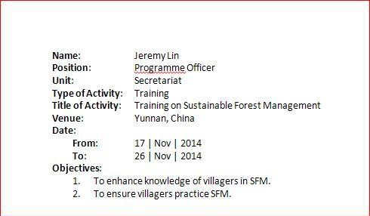

If you opt to use spreadsheet software such as Excel, assign a column for each item on your activity-recording form (see below). Collation using spreadsheets is relatively faster than for Word because all the data for a given period can be stored on the same spreadsheet, and numerical data can be summed automatically. However, a staff member must be designated to manage and update the spreadsheet, especially if there is more than one documenter. Documenters should double-check that entries have been made correctly.

The advantage of using web-based customized forms such as Google Form or Survey Monkey is that the data are managed and updated automatically by spreadsheet software (e.g. Excel); documenters can therefore enter data directly, and two or more documenters may add data to the database simultaneously. In certain circumstances

(e.g. where internet access is available in the field), data can even be uploaded in real time.

Form Data
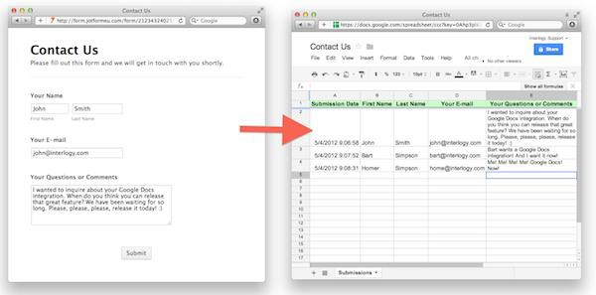

- Summarize or process stored information. Collected and stored information will be more useful if it is summarized or otherwise processed (e.g. number of meetings or field visits in a quarter, major issues encountered or lessons learned, number of men and women trained, total expenses incurred). Such summaries and aggregations will give the team a better feel for what transpired in a given period. The nature of the summaries will largely be dictated by reporting requirements. For example, if you are required to describe lessons learned in each reporting period, you should include it in the items that need to be extracted and summarized. Some kinds of data may be best summarized in graphs, which documentation software such as Excel and Google Forms can create for you.

- Share the summary with the team. It is good practice to share periodic summaries with all members of the project team, and potentially with stakeholders. Documentation summaries should form the basis of your progress and final reports.

- Summary

The 5 major steps in documentation are:
  - Designate a documenter for each major activity.
  - Develop a simple activity-recording tool.
  - Store and organize recorded information.
  - Summarize or otherwise process stored information.
  - Share the summary with the team.

Finally, the main purpose of documentation is to ensure that important project events and activities are properly recorded, stored, processed and shared; institutional knowledge is built on these simple steps. Most mature organizations and successful businesses

implement advanced documentation procedures. They invest time and effort to do so because they have discovered that it is a powerful method for ensuring they are moving in the right direction. Documentation is also a key component of effective project communication.

Annex D
Guide to web writing
The APFNet website is the main platform for disseminating information on APFNet projects and activities to the public. How APFNet is presented online, therefore, is crucial to its identity, and the rapid growth of electronic communication will only increase the importance of maintaining an active, high-quality web presence.
This annex provides guidance on how to write online content, project news and other updates for the APFNet website, as well as for dedicated project websites. It includes an outline of a basic web news article, and examples.

The difference between print and online publications

Printed publications are usually self-contained documents to be read from start to finish. Online material, on the other hand, tends to be sectioned into multiple, linked webpages, and each webpage must make sense on its own.
Readers of printed materials tend to access such material sequentially, but web readers are generally less patient and will click many links quickly as they hone in on their specific area of interest. Therefore, online content must be direct and easily understood.
Web readers tend to scan text rather than read it word-by-word. Therefore, the writing style of online content should be punchy, with short paragraphs.

How to write news for the web

Compile your facts

Before beginning to draft a web news article, make a list of all the pertinent information to be included.
The inverted pyramid

News articles tend to have an “inverted pyramid” format (see figure), which places the most important information at the top of the article. The reason for this format is to enable readers to grasp the main points of the article, even if they only read a few sentences. Most web news articles use the inverted pyramid format (but see sample 4 in this annex for an alternative approach for web features). They generally follow a format similar to press releases (see Annex F).

The inverted pyramid of news articles. The most important information goes at the top.

Lead
Most important information – five Ws and key messages Body
Less critical
information, as well as transitions and quotes

Web news articles should begin with the key message, followed by other points you want to highlight, and additional detail. In writing web news articles, the “five Ws” – who, when, what, why and where – are a good starting point. Consider adding quotes of experts or other key people in your story to add credibility.
Assume the reader knows nothing about the topic

It is likely that many web readers will find your web news article by chance (e.g. via a search). When writing online material, therefore, assume that the reader has no knowledge of APFNet or its projects. In practice, this means:
- Providing adequate background and explanation in the web news article or webpage.
- Avoiding jargon and highly technical terms.
- Spelling out acronyms the first time they appear in the article or on the webpage (and avoiding their overuse).
- Providing links to additional resources, where relevant.
Keep your language concise

It is possible to make a piece of writing simple while retaining substance, so get to the point. Use plain language to make your content clear and readable, which is especially important for web readers with relatively low English proficiency. In practice, therefore:

- Write short and declarative sentences in the active voice.
  - For example, write “APFNet implemented the workshop on 3 January 2014”, instead of “The workshop was implemented by APFNet on 3 January 2014”.
- Eliminate superfluous words and phrases.
  - For example, write “The stakeholders assessed …” rather than “The stakeholders performed an assessment on …”
- Use familiar words wherever possible. If a technical term must be used, briefly define or explain it so that it can be understood by an uninformed reader.
- Keep paragraphs short. Single-sentence paragraphs may be used in web writing, but, in general, aim to write paragraphs that are 3–4 sentences in length.
- Avoid repetition.
- Ensure that the text is free of spelling mistakes and grammatical errors.
Make your text easy to scan

Web readers tend to scan text for specific information or key words. To ensure that your text is easy to scan:
- Keep the vocabulary simple.
- Avoid long paragraphs, and make sure each paragraph has one main idea.
- Write subheadings that reflect the main idea of a section, and avoid using acronyms in headings.
- Use bulleted or numbered lists where appropriate, but keep them simple – complicated lists can confuse readers. Do not overuse punctuation in lists (e.g. avoid semi-colons, especially when list items are short).
- Ensure that all facts, figures and weblinks are correct.
Add visual appeal

Presenting information in a visually attractive way can help in grabbing and retaining the attention of readers. Writers should:
- Consider using graphics. Some information may be presented most effectively as a photograph, video, diagram, graph or chart. If so, provide sufficient detail in captions to ensure that readers can easily grasp the essential content of the graphic. For photos, identify the photographer.
- Break long passages of text into sections with subheadings.
- Break long paragraphs into several paragraphs, or use bullet points.

Write, re-write, edit and proofread

Good writing is rarely produced in the first draft. Rewriting, editing and proofreading will help ensure that your work is clear, concise and readable. If possible, ask colleagues to review the text – a second (and third) “pair of eyes” on your work will help ensure readability and accuracy. Set your draft aside for a day or so before re- reading it.

Basic news article outline

[Title, or headline]

- Keep the title concise, and try to capture the reader’s attention. For example, if you are writing a news article about an event that has happened, avoid simply stating that the event took place. Instead, use a title that highlights a conclusion or other point of interest that helps summarize the event. “New APFNet project will help improve Beijing’s water quality” is better than “APFNet launches new project on watershed rehabilitation in Beijing”.
- Consider using a subtitle – some webpages require subtitles as part of their styles. Subtitles may also be added as required, for example to expand on an eye-catching title that requires further explanation.
[Lead paragraph]

- The first or “lead” paragraph should begin with a sentence designed to grab the reader’s interest.
- State the most important information – the “five Ws”: who, when, what, where and why (and, perhaps, “how”).
- The lead paragraph is often only one sentence long and rarely longer than three sentences.
[Second paragraph]

- The second paragraph provides the background necessary for the reader to understand the context of the story.
[Opening quote]

- Use a strong quote that restates the key message of the story and perhaps includes a strong opinion.
[Main body – multiple short paragraphs]

- After giving the main facts of the story you may include additional information, such as project rationale and objectives, existing local challenges,

stakeholder perspectives, and how project interventions are designed to improve or change the situation.
- Ideally, each paragraph will begin with a fact or quote “set-up”, followed by a quote. The quote set-up should paraphrase the quote or put forward a fact or concept that the quote will support.
[Closing quote or conclusion]

- Use a quote to end the article that reinforces the key message.
- Instead of a quote, write a concluding sentence – perhaps indicating an expectation regarding the future impact of the intervention or potential future developments, or providing additional background information.
Other elements

- Include graphics (e.g. photos, maps and diagrams) as relevant. Country maps displaying project sites may be helpful to readers.
- Provide captions to explain what is happening in graphics.

Examples of web news articles

Example 1 – news article on project launch ceremony (source: APFNet)

New project will help improve Beijing’s water quality

An APFNet project on watershed rehabilitation aims to tackle Beijing’s long- standing water-supply challenges

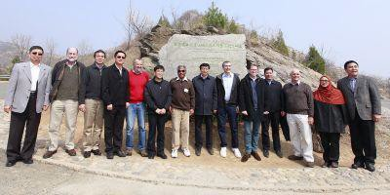
The APFNet Board of Directors gathers to mark the launch of an APFNet project at the Miyun Reservoir Watershed project site near Beijing
Beijing, China, 9 April 2015 – APFNet launched a project today aimed at reducing forest degradation and improving forest management in the Miyun Reservoir Watershed.
The project, titled “Rehabilitation and Management of Degraded Forests in Beijing’s Miyun Reservoir Watershed”, was launched at a tree-planting ceremony in the village of Shicheng in the Miyun Reservoir Watershed. Eleven members of the APFNet Board of Directors joined the Board’s chair, Zhao Shucong, in inaugurating the project. The Beijing Forestry Society (BFS) will implement the project under the supervision of the Beijing Municipal Bureau of Forestry and Parks.
According to BFS Project Director Mr Li Hao, considerable progress has been made in improving Beijing’s urban water management in recent years, but the pace of progress has been unable to match the rapid increase in the urban population and the consequent pressure on the water supply. Improvements are needed in forest management.
“The Miyun Reservoir Watershed provides over 60% of Beijing’s surface drinking water,” said Mr Li. “Forests account for 70% of the total watershed area and help protect against soil erosion and other factors that could cause water quality to decline. Improving their management is essential for the well-being of Beijing residents. ”

The project will develop three demonstration sites on 280 hectares of degraded forestland, raise forest management awareness and knowledge among local communities, and implement sustainable community development initiatives to improve local livelihoods.
The project launch ceremony and tree-planting took place during a field trip to Shicheng village in the outskirts of Beijing as part of the first meeting of the APFNet Board of Directors.

Example 2 – photo story

Safeguarding Bangkok’s green lung

The future of Bang Kachao rests with the next generation

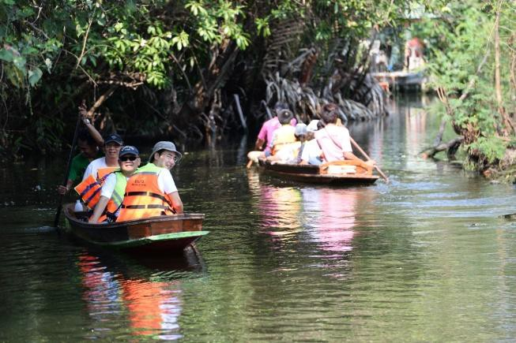
Activities on the Chao Phraya River included ecological restoration and ecotourism.
In the heart of Thailand’s capital of Bangkok, an urban refuge stands out from the concrete jungle like a giant “green lung”. This is the nickname given to Bang Kachao, an island reserve under the supervision of the Thai National Environment Board since 1977.
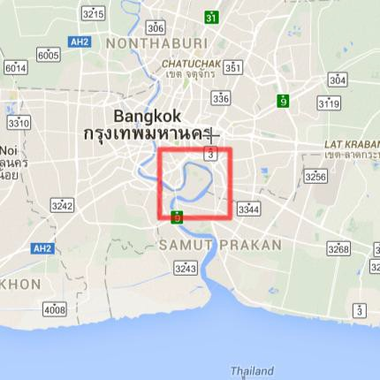Voted by Time magazine as the “Best Urban Oasis of Asia” in 2006, Bang Kachao covers approximately 5000 acres of land encircled by an oxbow curve on the Chao Phraya River. A layer of rich flora and fauna make up 80% of the island.

Bang Kachao is an island encircled by an oxbow curve on the Chao Phraya River (shown in red)
However, increasing industrial development and urbanization pose a risk to the preservation of the island reserve, and key to its survival is the level of environmental awareness and value amongst Bangkok’s younger generation.

In 2012, APFNet launched the Demonstration Project on Urban Forestry in Thailand, which established a natural learning center to encourage youth participation in urban forestry, promote ecotourism and direct urban forestry benefits to local communities.

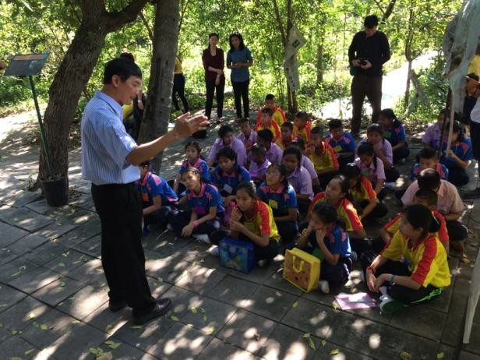

At the natural learning center, presentations are given to primary and secondary school students on forest ecosystems, sustainable forest management and the public’s responsibility to protect natural resources.

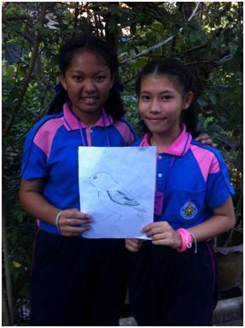

Students learn about Bang Kachao’s wildlife through activities including arts and crafts.

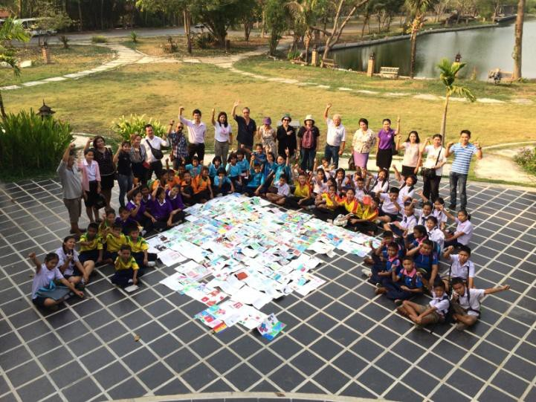

Outdoor painting is a popular activity among students.

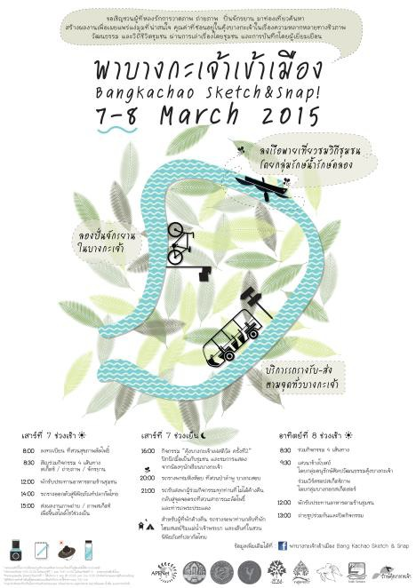

The Bang Kachao Sketch & Snap event featured bicycle riding, photography, tram rides and local art to promote the island’s history, culture and ecosystems.

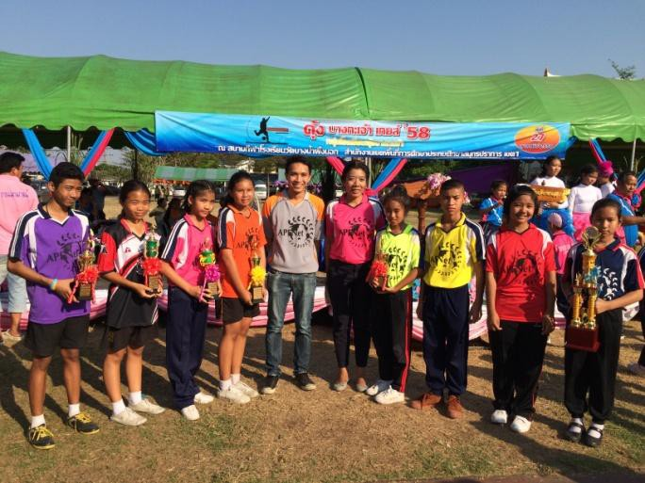

Students can participate in athletic activities at the Bang Kachao natural learning center.

Example 3 – feature story The following is a web feature story (based on a web article posted originally by the Center for International Forestry Research). It departs from the inverted pyramid structure of most web news articles.

Global study busts myths about forests and livelihoods

Findings of 10-year project could upend conceptions of how forests, people interact

20 March 2014: Forests play a crucial role in sustaining people’s incomes – but to what extent? Development actions related to forests and livelihoods are usually based on incomplete or fragmented data. In many cases, forestry is combined with agriculture in national income statistics – or not counted at all.
Now, in the most comprehensive study on the links between the environment and livelihoods to date, researchers have challenged conventional wisdom about the importance of environmental income, the roles of men and women in forest-product use, and the function of forests as safety nets. According to the study, income from forests and other natural environments makes a significant contribution to the livelihoods of millions of people in developing countries, although not always in the ways case-study research had previously suggested.
The global study is a product of the Poverty and Environment Network (PEN) (www.cifor.org/pen), a collaborative effort led by the Center for International Forestry Research. Five complementary research papers tackle the themes of income generation and rural livelihoods; safety nets during shortfalls; gender and forest use; forest clearing and livelihoods; and tenure and forest income. The papers – from which preliminary findings were released in 2011 – will appear in an upcoming special issue of World Development.
The study, which collated data from 58 tropical research sites worldwide, found, among things, that:
- Income from natural forests and other natural areas accounts for 28% of total household income – nearly as much as crops.
- State forests generate more income than private or community forests.
- Men generate at least as much household income from forests as women do, contrary to a common assumption.
- Forests are less important than previously believed as “safety nets” in response to shocks and as gap fillers between seasonal harvests.
- While the most destitute farmers are often blamed for deforestation, they play only a modest role in forest clearing.
Sven Wunder, lead editor of the forthcoming special edition of World Development, said: “Our results indicate that, even some 10,000 years after the start of the

Agricultural Revolution, rural people in developing countries still depend strongly on foraging from nature for their livelihoods.”

Annex E
Newsletter production tips

Important factors for creating effective newsletters

Project newsletters are helpful for sharing information on the progress and achievements of projects and for publicizing related events and disseminating important announcements.
In producing effective newsletters, APFNet project managers should consider the following:
- Alignment with overall communication strategy. Determine what you wish to achieve by sending out newsletters. How would a newsletter align with and add value to other project-related communication, visibility and dissemination activities?
- Clearly identified target groups. A common goal of newsletters is to build and maintain awareness among target groups. Typical audiences groups for project newsletters are:
  - Policymakers in the forest and environment sectors
  - Foresters, researchers and members of academia, non-governmental organizations and other technical stakeholders
  - Project beneficiaries, such as local communities
  - Media and press
  - General public.

Newsletters may be produced with a specific group in mind, or they may be directed at several groups simultaneously. It is important that the tone and language of the newsletter suits the target group or groups; in some cases, different versions of a newsletter may be needed to reach different groups.
- Regular issues produced on time. The timing, frequency and length of a newsletter should be determined according to need. If the aim is to ensure that local stakeholders are fully aware of project developments, a frequent but brief newsletter may be appropriate. If the aim is to inform external stakeholders about project progress and achievements, a longer but less frequent publication may be suitable. Be realistic about the amount of content it will be possible to produce: developing a consistent newsletter structure and preparing a clear timetable for all written, editorial and publication tasks can help achieve this.
- User-friendly format and attractive presentation. All editions of a newsletter should use the same design, with the edition number clearly displayed. The

consistent use of the same design provides the newsletter with identity and credibility and avoids the need and expense of “reinventing” the newsletter for each edition. An uncluttered, attractively designed newsletter encourages readers to start – and continue – reading: use a simple design and good-quality photos, and achieve an appropriate balance between text, images and “white space”.
- Easy-to-read and carefully edited text. Keep the text concise and in the active voice. Edit for clarity, conciseness and accuracy. Avoid jargon, or ensure that it is explained clearly, and cite information sources. Refer to Annex D (“Guide to web writing”) for tips on writing articles.
- Electronic or traditional format. Many contemporary newsletters are developed and delivered in html or other email- and web-friendly format. Advantages of such formats compared with other forms (e.g. PDFs for electronic distribution, and paper copies) include lower production costs (e.g. in design, printing and distribution) and shorter production times. Disadvantages include the risk that recipients will ignore them as part of information “overload”, their inaccessibility to stakeholders who lack web access, their high “disposability”, and their often lower visual appeal compared with PDFs and printed newsletters.

Make it a team effort

Newsletter production should be a team effort, rather than a one-person project. Combining the support and skills of multiple players will significantly increase the effectiveness and quality of a newsletter. Typical roles in a newsletter production team are:
- Coordinator – in charge of the schedule, keeping team members on task, and ensuring that each team member is clear on their responsibilities
- Writer(s) – writes newsletter content.
- Contributing or guest writer(s) – typically experts or other writers who have specific knowledge of the subject matter.
- Editor – ensures that the tone and content of the newsletter are consistent, and proofreads for language, grammar, spelling mistakes and other errors. Ensures that the final product is ready for publication.
- Designer – develops the newsletter’s mockup, color scheme, design theme and layout. Usually the designer will develop a template that can be re-used for new issues. He or she may also obtain and adjust photos and illustrations.
- Publisher/distributor – responsible for finding the most effective distribution channels (email, print or other) and sends the final version to recipients.

Types of newsletter articles

The common types of newsletter articles are:

- Fillers (100 to 150 words)
  - News briefs
  - Upcoming activities and events
  - Short messages or announcements

- Short articles (200 to 300 words)
  - Consists of a main paragraph with the most important information (the “5 Ws”
– see Annex C) and sometimes supplementary information
  - Should have an “angle” or perspective that makes the article unique and attracts attention
- Feature/major articles (500 words or more)
  - Follows the standard structure of a news article with a main paragraph (“5 Ws”) and subsequent paragraphs
  - Often consists of interviews or perspectives of experts or relevant individuals
  - Has an angle or perspective that makes the article unique and interesting
  - May involve the use of side panels, quotes or fact boxes to break up the text and make reading easier (these may be 50–125 words in length and consist of key facts, figures, quotes or other information that adds depth to the article)

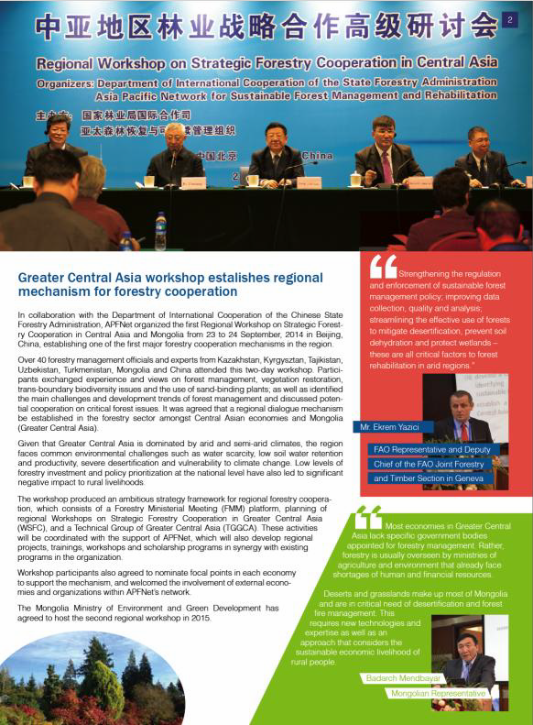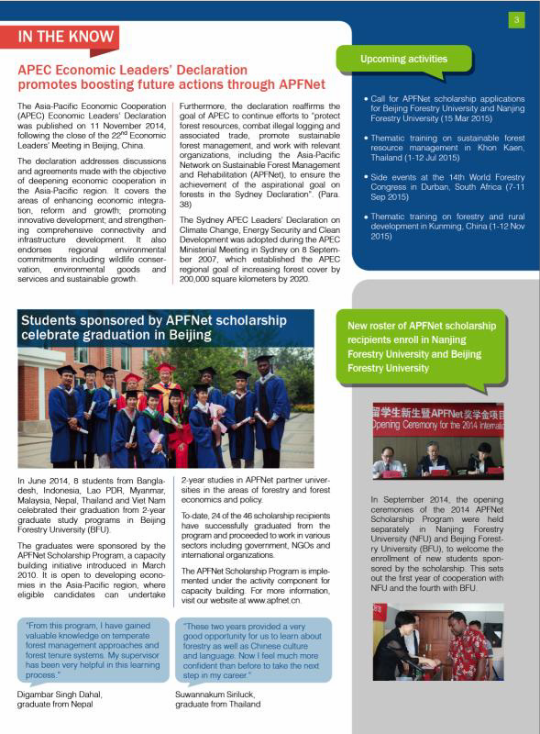

Extract from an edition of the APFNet newsletter – This page contains a feature article and quote boxes on the right
This page contains short articles (left) and filler articles (right). Filler articles help break up long bodies of text and add variety.

Annex F
Guide to writing press releases
- When should you write a press release?
Before starting to write a press release, ask yourself the following questions:

- Is the intended press release relevant to one or more of the intervention’s objectives? If the answer to this is “no”, you probably don’t need the press release.
- Does the press release have a strong message relevant to the intervention? If the answer is “no”, you may be promoting someone else's work — there might be a good reason for this, but remember that your primary role is to promote the intervention’s objectives.
- Do you have articulate spokespeople who will be able to respond convincingly to journalists on the subject matter of the press release?
- Does the press release present new information for the media and the general public? Do you have a forthcoming event, a new report or discovery, or new research?
- Do you have a hook for the press release? A hook is a link to an international conference, recent events, a new report, etc., that will make your announcement topical.
- Does your presss release present unusual facts and situations that might grab the attention of the media and the public, or does it carry strong arguments for or against something, which might prompt a wide debate and raise the profile or your intervention?
- Is your press release solution oriented? If a press release exposes a problematic situation, it must contain recommendations to solve the problem.
- Does the press release put the intervention’s “story” in a wider context? For example, does it relate to a bigger-picture story such as land degradation, the value of environmental services, or human rights?
Having asked and answered these questions, you are ready to take the next steps.

- When should you issue the press release?
Think about whether you have a good hook for your release. If so, think about when journalists may need to receive the information in order to use it in a story related to your hook.
Also think about whether you need to embargo your news. Under an embargo, journalists can gain access to the news but are unable to publish it until the embargo expires.

Hint: Are major announcements pending in your target country (or countries) that might compete with your story for space in the news? Are other NGOs issuing press releases? Try to avoid days when you will have serious competition for media attention.
If there is no external constraint on the date for issuing the release, think about which day would be best for journalists. Generally, Friday is a bad day for news. Does a major newspaper have an environment section on a specific day? If yes, think about releasing your information the previous day (and working with the editor of the section to ensure good coverage).
When you have a good idea of when you want to issue the press release, check that your spokespeople will be available for the days surrounding the release to answer media queries.
- Preparation
When you have decided to write a press release, and the day on which you plan to issue it, think about how the media might receive the release and the extra questions they might ask
— then make sure you have answers ready for such questions.

Hint: Prepare a question-and-answer sheet (“Q&A”) on the subject matter of the press release and clear it with the relevant people. For example, if the press release pertains to a new report, clear the Q&A with the report’s author(s).
Make sure that what you plan to say in the press release is coherent with APFNet’s policies. You can check this with APFNet project managers or communication staff.
Think about who your key audience is. What is the best publication, website, TV program, or radio program for reaching that audience?
- Writing the release: what structure should I use? (This structure also commonly applies to web articles and newsletter articles)
There are various ways to write a press release, but usually they all have a similar starting structure: headline, an opening paragraph that summarizes the key message, a second paragraph, which contains additional detail, and a quote.
Think about the main thing you want someone to know about your story, and try to say it in one sentence. This is your headline.1 The media is inundated with many similar stories, so try to be original with your idea – look for an angle and whether you can add a unique selling point. The event or publication generates your story (e.g. award, big contract, major

1 Some press releases have a short, catchy headline and a longer subheading to provide more explanation.

decision or finding), but the headline is the first step in “selling” the story. It is the first thing that a journalist or editor will read, so grab their attention. Give the editor or producer a headline that will sell the story. Many great stories have been binned because the headline failed to excite.

Once you have captivated the editor or producer with your headline, you need a paragraph that tells them what the press release is about – this first paragraph should explain exactly what is going on. Don’t make it too long – it must be brief enough to sustain the interest of the journalist, editor or producer (two or three sentences), and it must tell the story.
Your second paragraph should give more information and background on the story. It should quote facts: your story will be more compelling if you provide hard data.
The third paragraph should be a quote from a relevant expert or commentator (e.g. the executive director of the organization or the lead writer of the report). As the writer, you can devise the quote and consult with the spokesperson to ensure they are comfortable with it.
Hint: Read through newspapers to see the kinds of quotes journalists use and try to write something like this. It should sound like something a person would say — and not as if it is lifted from a report.
The quote should be snappy, and it should reinforce the key message. It should also make sense on its own, in case journalists decide to use the quote but not the contextual material in the press release. Depending on the topic, there may be value in quoting a second and even a third person, for example from partner institutions, as a way of verifying and adding weight to the point of view of the first spokesperson.
Overall, the release should be structured with the most important information high up in the release, and supporting information down lower. A journalist should not have to read to the end of a press release to find out crucial information. The press release should make sense and tell the story, even if all but the headline and the first one or two paragraphs are deleted. Additional information can be added in paragraphs towards the end of the release, with the aim of adding “texture” to the story.
You may wish to end the release with another quote.

Perhaps the most important rule to remember in writing press releases is to be accurate. Do not make up information. In an effort to devise an eye-catching hook, do not exaggerate. Review each statement in the press release to ensure that you can justify it with evidence.

- How long should the release be?
Try to keep press releases to one page because few news journalists will read beyond the first page. Keep the style fluent and in line with the issue/event you are trying to publicize, and avoid repetition.
- Sign off
You should always get sign-off for your press release – from a project leader, country coordinator, communication manager or executive director (or a combination of these). Quotes should be checked and cleared with the people to whom they are attributed. Journalists view the contents of press releases as presenting the official positions of issuing organizations — make sure that nothing you say will discredit the organization.
- What should the release look like?
Use the APFNet press release template (below) for your press releases. Text within the release should be single space with short paragraphs.
If the information is embargoed, state a time, day and month e.g. The date must always be at the top of the release — eg Not for distribution before 13.00hrs on 5 April 2014
If it is for immediate release you should put: “For immediate release - [date]”

Make sure you include contact information for the press officer or project coordinator. Make sure that anyone listed will be available for at least 48 hours after the press release is issued.
Additional relevant information not included in the main text of the press release can be added in a section called “Notes for editors” at the end of the press release, along with links to photos and video footage to illustrate the story. If you are offering photos, make sure you have the right to use those photographs and that the photographers are credited.
Consider whether you need to provide background information, such as factsheets summarizing the event, report or other hook and about the organization issuing (or mentioned in) the press release.

PRESS RELEASE

******** EMBARGOED UNTIL [DAY] [MONTH] [YEAR] ******** For more information please contact:
[Name of press officer]: [email address]; [telephone number]

[Write headline here, one or two lines in length]
[Consider whether you need a subheading, no longer than three lines, to put the headline in context]

[Date of release], [location of event, etc.]: [First paragraph, which states the key message in 1–3 sentences.]
[Second paragraph, four or five lines in length.]

[Quote from key spokesperson, which restates the key message and perhaps adds a strong opinion. The paragraph should include the name of the person being quoted, and their title and organization.]

[Subsequent paragraphs can give additional information and more quotes, including from a second and even third spokesperson.]

[Closing paragraph - can be a quote. One option is to “complete” the story by reiterating the key message.]

[“Notes for editors” can be added at the bottom to provide additional background information as well as links to factsheets, photos and video footage.]

Annex G APFNet Communication Guide

Annex G
Stories of change guiding questions
What point about your work will this story convey? (e.g. the impact of a project on a community, or the lessons to be learned from a project)

Who is the protagonist of your story? (Whom will the audience follow or identify with through the narrative?)

What does the audience need to know about the protagonist at the outset to understand his (or her) “world in balance”? (e.g. What is the person’s situation before the intervention?)

What is the “inciting incident” that upsets this balance and sends the protagonist in pursuit of a goal? (e.g. What happens – for example as a result of the intervention – that stimulates the protagonist to change behavior?)

What is the protagonist’s goal?

What is the first barrier standing in the protagonist’s way (that this can be internal or external)
and how does the protagonist overcome it? What role does the intervention play?

Describe any subsequent barriers and how they are overcome. (The protagonist may have only one barrier, but the more you can find, the more interesting the story will become.)

What is the resolution of the story? (Does your protagonist achieve his/her goal, or is there another outcome?)

What is the meaning of the story? What do you want the audience to take away? (e.g. What lesson can be learned to benefit future interventions?)

How does this story relate to the intervention? (Is it emblematic of its purpose?)

To what audience would you want to tell this story? (Public? Legislators? Donors? Internal? Some combination of these?)

Annex H
Introduction to project photography
There is no shortage of photos these days. Who hasn’t been to a workshop at which hundreds (or even thousands) of shots have been taken of pretty much the same thing (e.g. participants sitting and listening) and rarely looked at again?

Before the advent of the digital camera, photos were rarer and more valued. Camera film was expensive, and so was film development. Before the digital age, photographers were selective in their shots to avoid wasting film and money. Every shot was precious.

Today, anyone can take hundreds of photos using their mobile phones, digital point-and- shoots, or digital SLR (single lens reflex) cameras. You don’t have to worry too much about taking too many because your device can store hundreds of high-quality photographs.

Digital technology makes photo documentation easy in projects, but there are risks because, although we all have digital cameras, we don’t necessarily have the skills to take good photos. Here are some tips to help you take useful, good-quality photos of your project activities.

- Familiarize yourself with the activity and venue so you can plan “perspectives” for your shots, possible subjects, and where to position yourself for particular speakers or activities.
- Make your photos tell a story. A hundred unplanned photos may not tell a story, but a few well-chosen shots can. This is the rule of thumb in photo documentation: strive to take photos that will be useful in telling what transpired in the activity. If you keep this in mind, it will significantly add value to the activity report. For example, if a “lesson learned” is likely to be that tending seedlings is essential in the first six months, make sure you obtain good photos of this activity.
- Observe, then shoot. It is tempting to simply fire away at the “main event”, but make it a practice to pause and look around. You may be surprised at how many interesting subjects there are in the periphery of the main event that add interest and information it.
- Take photos of people in action (and smiling). Photos are nearly always more interesting when they have people in them. Try to balance your shots between people in action and people in repose. The best photos are usually those in which people are smiling, but it is not always necessary for them to be looking at the camera.
- Organize your photos. You should upload your photos to your computer immediately after the activity. Make it a habit to name your folders and photos systematically (for example, folder and file names could contain information such as the project code, location and date). Photo storage software such as Picasa allows you to record captions, the photographer’s name and other details with the image itself, making later use in activity reports (and other communication products) much easier.

The technical aspects of photography are discussed further below.

What is photography?
Photography is the science, art and practice of recording light using electronic image sensors or photographic film. Taking good, informative photos of activities is an essential element in APFNet project implementation.

The word “photography” has Greek roots; it means “drawing with light”. (Wikipedia)

Photography in the context of APFNet interventions
Good-quality, systematically organized digital photographs are essential for illustrating the purposes of APFNet interventions and showing the benefits they provide. In APFNet-funded projects, the aim should be to show the diverse field activities undertaken, the landscape (and potentially social) changes brought about by the project over time, and the beneficiaries of project outputs and outcomes; photos are usually most interesting when they feature people engaged in relevant activities.

APFNet particularly seeks photos of project field sites; nurseries and seedlings; local communities and community activities; and events (e.g. workshops, meetings and conferences). All photographs should be accompanied by the following information: photographer’s name, the date and location of the photo, the activity shown in the photo, the names of people in the photo (where available), and other relevant information. The present document introduces some of the basic concepts involved in taking high-quality photos that should be applied in project-related photography.

The camera: your tool for recording light
The camera is a tool for recording light. Cameras can be thought of as an extension of the human eye, which is also a device for capturing light. Table 1 lists the components of a camera and their equivalents in the human eye.

Table 1. Camera vs. human eye
Components to capture light | Camera | Human eye
Lens | Yes | Yes (lens)
Shutter | Yes | Yes (eyelids)
Light meter | Yes (automated system operating “through the lens”, or TTL) | Yes (lens, cornea) through the lens
Focusing ring | Yes | Yes (lens, cornea)
Aperture | Yes | Yes (pupil dilation)
Image sensor | Yes | Yes (retina)
Image storage | Yes, memory cards | Yes, brain (memory)

Table 2 shows the major components of cameras, and their functions.

Table 2. Major camera parts and their functions (conventional SLR, phone and digital SLR)
Component | Function
Shutter button | Open/close shutter
Light meter (TTL) | Determines correct amount of light for a particular scene or subject
Lens | Collects and focuses light on image sensor or photographic film
Aperture | Controls the opening of the lens to allow light to pass through
Focusing ring | To keep the subject in clear focus
Shutter speed | Controls the amount of time the shutter is open to receive light
Image sensors | Translates light into images
ISO setting | Controls the film or image sensor sensitivity to light
Memory | Stores images

What makes a good photograph?
Technically, a good photograph is one in which the subject is in sharp focus and which is properly exposed (that is, the digital sensor or film is exposed to the right amount of light). Exposure is determined by the shutter speed, the size of the aperture, and the ISO setting. Most digital cameras have a standard ISO setting and automatically adjust shutter speed and aperture size (using TTL technology) to achieve the correct exposure. In some cameras it is possible to set these parameters manually, too.

Another essential parameter of a good photograph in the digital age is resolution – always set your camera to record images at the highest-possible resolution. The resolution of any given photo, once taken, can be reduced (for example if a smaller file size is needed), but it cannot be increased.

What makes a photograph stand out?
Photographers should always consider the following four basic elements in taking high-quality photographs.

  - Subject – the subject is the primary subject of interest on which a photographer focuses. Choose a subject that is relevant to the message you would like to convey.
  - Composition – Composition is a way of guiding the viewer’s eye towards the most important elements of an image; composing the image means arranging elements within it in a way that suits the main message you are trying to convey. Poor photo composition can make a good subject dull, but good composition can create an excellent image from an ordinary situation. In the field, for example, a fence line can be included in a photo to direct the viewer’s eye to the subject. Taking a photo of a speaker at a conference, it might be possible to include an informative background (e.g. words on a screen) to add interest to the photo. Here’s a link to a website with
helpful tips for good photo composition.1
  - Timing – Timing is about the moment at which you take the photo. For example, a photo of a speaker at a conference could be taken when the speaker is looking at his

1 www.digitalcameraworld.com/2012/04/12/10-rules-of-photo-composition-and-why-they-work.

or her notes, which is likely to be uninteresting, or when the speaker is looking at the audience and making an impassioned point – which will be more dynamic and more likely to convey the speaker’s emotion. In the field, timing might be about capturing an action like tree-planting at the moment that is most interesting and informative (e.g. just before the seedling goes into the ground). Digital photography makes it easy and cheap to take multiple shots of the same subject, increasing the chances of getting the timing right.
  - Aesthetics – The aesthetics of a photo are largely determined by the way light is used. In outdoor settings, the most attractive shots are usually taken early in the morning (the first hour or so after dawn) or towards evening (the last hour or so before sunset), sometimes called the “golden hour”. The light is softer and warmer and produces less contrast in the golden hour, reducing the strength of shadows that can mar an image. On the other hand, the long shadows produced in the golden hour can add depth and texture to an image. Many photographers use software to manipulate their images, but good photos rarely require much, if any, such manipulation (perhaps other than cropping).

These four characteristics cannot be automated; they require skill. Some photographers have natural flair for taking good photos, but awareness of these four characteristics, and practice at them, can make a huge difference to anyone’s ability to take stand-out photos. Additional aspects of good photography are explored below.

Must-know concepts in photography2
Exposure. If you shoot a daylight scene with an aperture that is too large, a shutter speed that is too slow, and/or an ISO setting that is too high, you will end up with a glaring, unattractive image with little discernable detail. On the other hand, if the aperture is too small, the shutter speed is too fast or the ISO is set too low, the scene will look dark and murky. Balancing shutter speed, ISO and aperture to get the correct exposure is one of the keys to good photography.

Aperture or F-stop. “Aperture” and “f-stop” are closely related terms. Aperture refers to the opening in the lens through which light shines when a photo is taken. The larger the aperture, the more light gets through. F-stop is simply the nomenclature photographers use when discussing different sizes of aperture.

- stops are indicated on a standard scale, from “f/1” to “f/128” (see the scale below); counterintuitively, a higher f-stop indicates a smaller aperture. Each step in the scale reduces (or increases, depending on the direction you move along the scale) the amount of light allowed through by about half. For example, an f-stop of f/8 allows through half as much light as f/5.6.

f/1, f/1.4, f/2, f/2.8, f/4, f/5.6, f/8, f/11, f/16, f/22, f/32, f/45, f/64, f/90, f/128

2 Grabianowski, Ed. “10 important photography terms”, 7 December 2010. HowStuffWorks.com.
http://electronics.howstuffworks.com/cameras-photography/tips/10-important-photography-terms.htm, 20
August 2015.

Depth of field. You've probably seen beautiful photos of flowers that are close to the camera and in crisp focus, while the background is soft and fuzzy; such photos have a narrow depth of field. Depth of field is a measure of the distance between the nearest and farthest objects that are in sharp focus in a photograph; it can be defined as the zone of sharpest focus in front of, behind, and around the subject of the photo.

Depth of field can be very narrow (for example, a photo of a flower in which only one petal is in focus), or effectively infinite (e.g. in landscape photos in which everything in the image is in focus). The main determinant of depth of field is the aperture size. A large aperture (i.e. with a low f-stop number) will give a narrow depth of field, and a small aperture (i.e. with a high f- stop number) will give a large depth of field.

There is no “best” depth of field. The desirable depth of field depends on the purpose of the photo.

ISO number: ISO is a measure of sensitivity to light. It originally referred to the light sensitivity of film, and the standards for measuring were determined by the International Standards Organization (ISO) (hence the name of the measure). The term ISO is also used in digital cameras as an indicator of the camera sensor’s sensitivity to light.

In a film camera, changing the ISO required changing the film; in digital cameras, it can be changed in the camera’s settings.

Although it measures sensitivity to light, photographers refer to ISO as the “speed” of the film or sensor. At high sensitivity, more light is sensed in a given period (i.e. the length of time the shutter is open) than at low sensitivity; high sensitivity is therefore considered faster. A low ISO number indicates a low sensitivity to light (“slow” speed), and high ISO numbers indicate higher sensitivity (“fast” speed). A high ISO number is used in capturing fast-moving subjects (e.g. cars racing around a track); a low ISO number is more suitable for low-light conditions (e.g. at dusk).

Shutter speed. Shutter speed, the third part of the exposure equation (exposure = aperture + ISO + shutter speed), is the length of time the camera shutter stays open to capture light. Shutter speeds are given in fractions of a second; in normal daylight conditions, a shutter speed of about 1/500 (i.e. one five-hundredth of a second) is about standard.

Slow shutter speeds allow in more light, but they can also cause blurring. Light hits the sensor for the entire time the shutter is open; if an object (or the camera itself) moves during that time, the movement will blur the resultant image. Mounting the camera on a tripod when using slow shutter speeds can help reduce blur caused by camera movement.

Photography do’s and don’ts
Table 3 provides some basic “dos” and “don’ts” in digital and conventional photography that can help you become a better photographer. Note that that there are many more “do’s” than “don’ts”. Rules in photography can be broken. Dare to experiment!

Table 3. Do’s and don’ts in digital photography
DO | DON’T
Invest in a good-quality camera. Phone cameras are getting better, but specialist cameras are more flexible, have more features, and generally have better lenses | Buy a camera without making sure it has the features you need
Know your camera! | Forget the instruction manual ☺
Use natural light, especially in the golden hours (the first hour after dawn and the last hour before sunset) | Shoot against the light or point your camera directly into sunlight (except to achieve special effects, such as silhouettes or diffused sunlight through tree canopies)
 | Shoot in the unavoidable | middle | of | day, | unless | it | is
Compose your photos carefully, making sure, for example, you don’t cut off people’s feet, or the tops of their heads | Crop the photo at the wrong places (e.g. not enough head room or head being cut off from the frame)
 | Use a flash in large rooms
Think about the depth of field that will best portray your subject and message and adjust aperture accordingly | Shoot too close to your subject, especially people
Keep your subject in focus (use manual focus if necessary)
Keep your lens clean
Bring extra memory cards and batteries
Think about the effect you want to achieve, and apply the four basic elements involved in taking high-quality photographs: subject, composition, timing and aesthetics
Take more photos than you think you need
Shoot subjects from several angles to see which works best
Try to be original – can you provide a new perspective that will add information and increase viewer interest?
Shoot subjects in action
Use a wide angle lens in limited spaces and to achieve special effects
Download photos from your camera to storage disks after each shoot, and clearly label each photo

Four scenarios3
Scenario 1 – wildlife (e.g. birds)
  - A zoom lens may be required to capture sufficient detail of the animal
  - High speed may be needed to freeze action (e.g. water birds taking flight from a wetland)
    - Use “shutter priority” setting
    - Set shutter speed to 1/800s
    - The light meter will set the aperture for correct exposure (e.g. f10)
    - If under exposed, change ISO to compensate (e.g. ISO400, which is relatively “fast”) Note: To show motion blur, set the shutter speed to 1/30 or 1/15
Scenario 2 – Portrait
  - An artistic narrow depth of field is desired
    - Use “aperture priority”
    - Set aperture to f5.6
    - The light meter will set the shutter for correct exposure (e.g. 1/160)
    - If under exposed, change ISO to compensate – ISO 100

Scenario 3 – Night scene
  - Ambient light is too low to accurately meter
    - Use “manual” setting
    - Use a tripod
    - Set aperture to suit scene, erring to wider – e.g. f11
    - Set a long shutter speed to light meter’s best guess – e.g. 20 sec
    - Set ISO to lowest possible for correct exposure – ISO 100
    - Take a test shot and adjust settings if the light meter got it wrong

Scenario 4 – Off-camera manual flash
  - On auto, meter the scene and note settings
  - Set camera to one or two stops under-exposed
  - Set up flashes and tweak power to expose correctly
  - Tweak the flashes exposure by adjusting aperture
  - Tweak the ambient light by adjusting shutter speed
  - Settings for example shot: 1/160sec f8 ISO125, click image for flash details.

Examples of project photos
The photos on the following pages were taken in APFNet projects. The accompanying notes indicate the good points of the photos, and how they might be improved.

3 Neil Creek. 2014. Photography 101.8 – The Light Meter. [ONLINE] Available at: http://digital-photography- school.com/photography-1018-meter/. [Accessed 20 August 15].

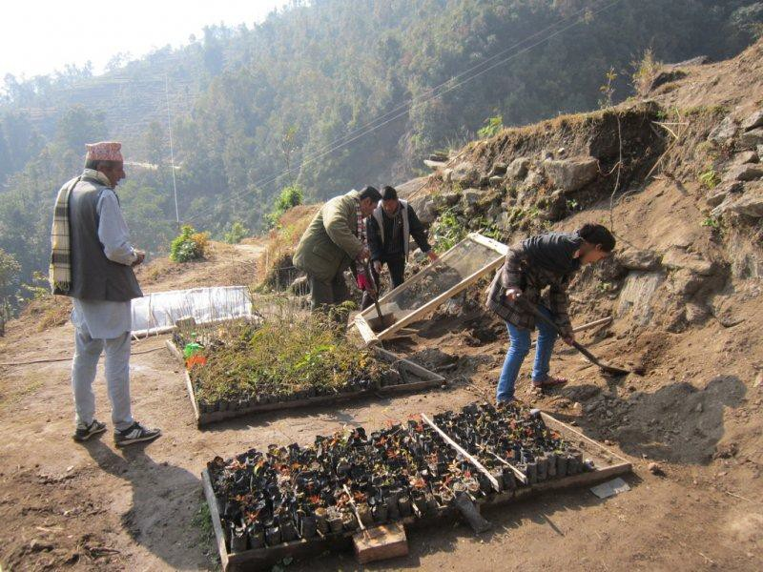Good points
- Taken early in the morning
- Informative of nursery process
- Two people involved in relevant action

How to improve
- Increase the resolution to make the image sharper
- Improve photo composition by:
  - harmonizing the activities of the two people using shovels and asking the others to remove themselves from the scene, or
  - reducing depth of field and changing perspective to increase attention on one of the workers and the task he or she is performing
- Consider making use of the diagonal lines of the seedling trays in the foreground to draw the eye of the viewer “through” the photo (a common technique in photography)
- Try to avoid including the power lines in the photo

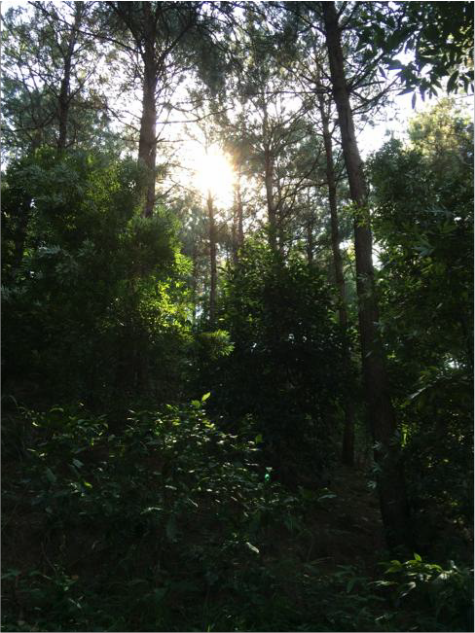

Good points
- Effective use of sunlight to “colour” the leaves of the canopies in the foreground and middle ground and thereby illustrate forest structure and suggest a luxuriant forest

How to improve
- Consider adjusting the perspective (i.e. the position from which the photo is taken, or the angle of the camera) to show the tops of some of the emergent trees (to better show the differences in height of the various canopy levels) and/or the ground level
- Consider including a person in the foreground (undertaking a relevant task) to give perspective and add interest
- Take the photo in the “golden hour” to achieve a more aesthetic result, if sufficient light is available

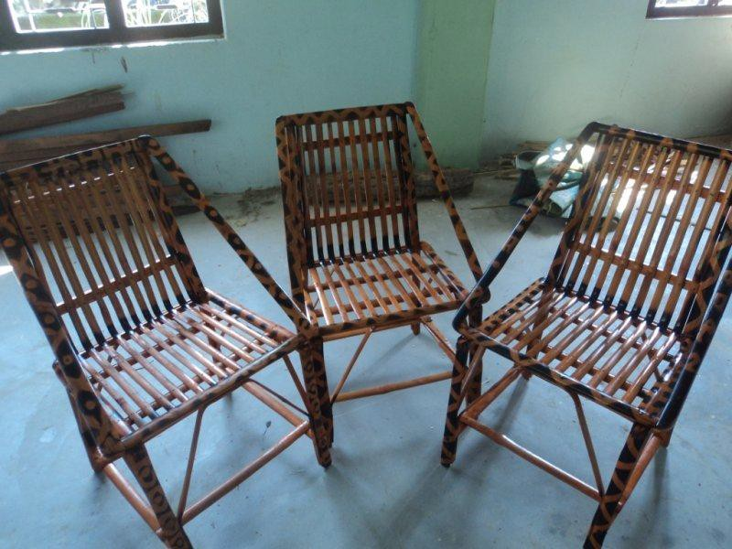

Good points
- Illustrative of products produced under a project

How to improve
- Place the items in a more attractive setting
- Show people sitting on the chairs
- Focus on one of the chairs and reduce the depth of field so that the chair becomes the primary subject
- Changing the angle of the chair (or chairs) to emphasize the diagonal lines of the slats, thereby drawing the eye of the viewer “through” the photo
- Improve the lighting to emphasize the natural colors and beauty of the product

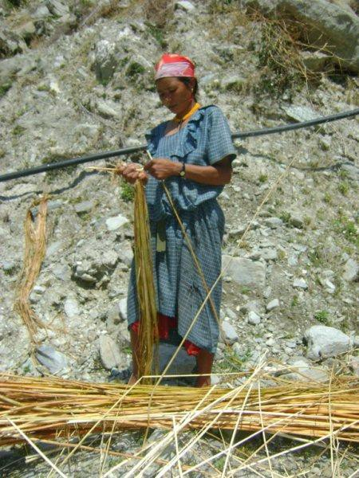

Good points
- Shows a local stakeholder engaged in a project-related activity
- Has an unusual perspective (from low down, giving the subject extra stature)

How to improve
- Increase photo resolution
- Reduce the depth of field to diffuse the unattractive background
- Use a zoom lens to bring the viewer closer to the subject and the activity in which she is engaged
- Try to avoid including the irrigation pipe in the background, which is distracting

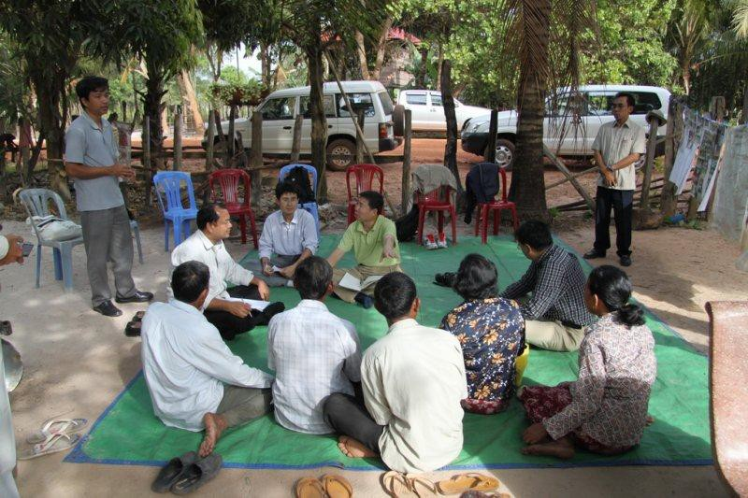

Good points
- Shows a stakeholder consultation, including women and men
- Authentic setting

How to improve
- Avoid showing parked cars in photos like this (taking the shot from the other side of the mat might bring in local elements, such as buildings)
- The two standing men (especially the one on the right) look somewhat authoritarian, reducing the sense of an equal consultation – try to avoid including them in the shot
- Consider taking shots at the same level as the people sitting down
- Consider taking close-ups of the people as they engage in conversation

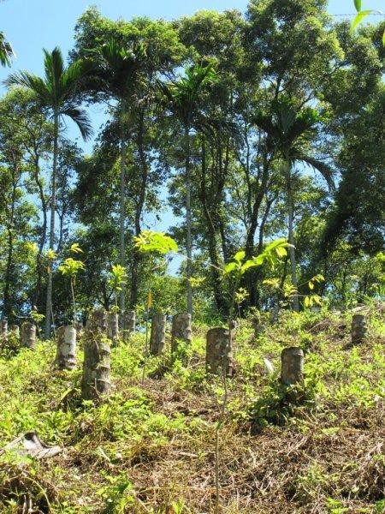

Good points
- Illustrates a component of a forest management regime (planted seedlings in a felled plantation)
- Strong colours

How to improve
- Zoom “out” slightly so that the tops of all the trees in the background are included
- Reduce depth of field to better show the subject (planted seedlings) against the background of taller trees (in which case it is less important to include the tops of the trees in the background)
- Choose one planted seedling to form the subject, using other seedlings for the background
- Take photo in the “golden hour” to improve the aesthetics

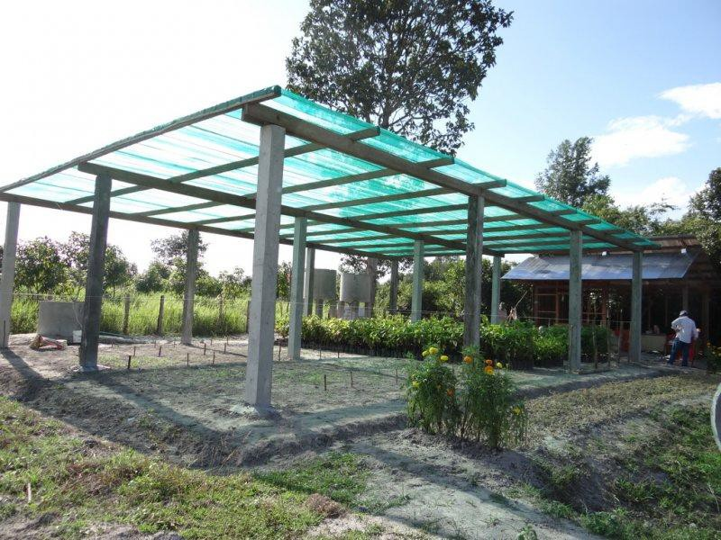

Good points
- Shows a project product (nursery shade house)
- The diagonal lines of the beams give dynamism to the photo
- The flowers in the foreground add colour and interest

How to improve
- Take photo in the “golden hour”
- Zoom out so that the partly cropped upright on the left-hand side is fully visible
- Don’t include the person on the far right of the photo, who is a distraction
- Invite a nursery worker to pose in the foreground of the photo. This person could be undertaking a nursery activity, or could be smiling at the camera. With a small aperture, both the person in the foreground and the shade house in the background could be in focus

Annex I APFNet Communication Guide

Annex I APFNet Logo

